Collision Avoidance Robot

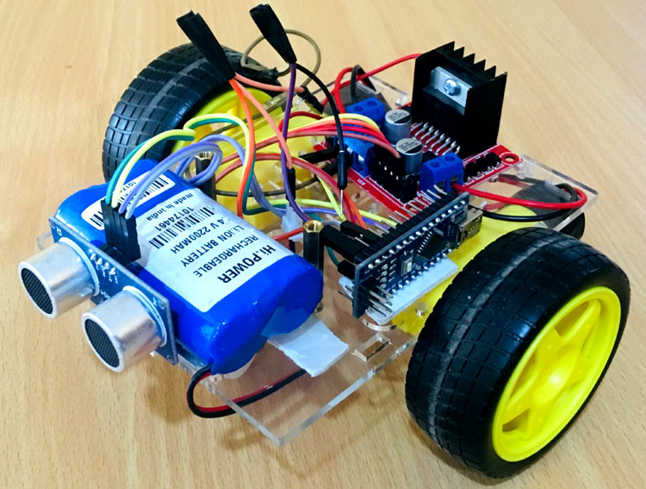

# System Explanation:

Our robot hear is doing a simple task just move forward and stop if ultrasonic read a distance smaller or equal to our threshold (in our case is 50)

# Block:

Figure 1-System block

We have 3 modules Ultrasonic , DC motor the robot itself .We get reading from the ultrasonic then send it to the robot the robot sees if the signal will make him stop or move by comparing it with the threshold (the signal is the distance read by the ultrasonic) if less than or equal then we send signal to the DC motor(speed in this case) to stop if distance bigger than we send signal to move (speed bigger than 0).

# Flowcharts:

Figure 2-DC motor flowchart

As we see in the flowchart the robot moves when it gets a speed then back to its idle state.

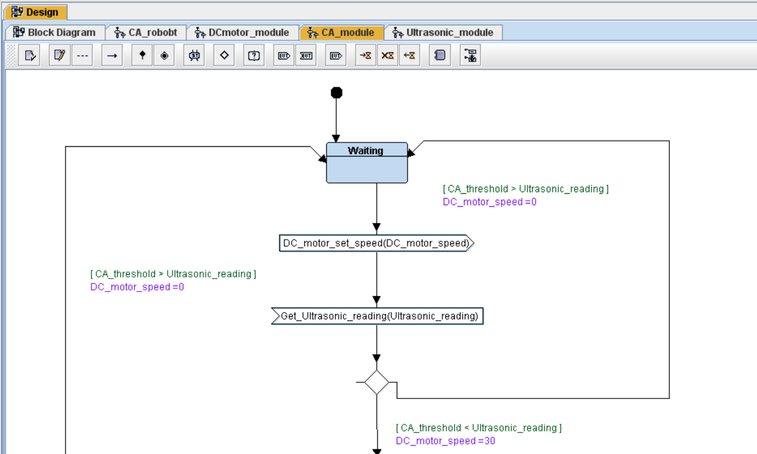

Figure 3-Robot Flowchart

Our robot here begin in waiting state then receive signal from ultrasonic of the readings if it is allwable to move (bigger than threshold which is 50) then sets speed to 30 and send it to the DC motor then check again to see if it will wait or continue moving.

Figure 4-Ultrasonic flowchart

In our flowchart it will send ultrasonic readings we did it by giving a random value within a range from 40 to 60

Figure 5-System

As we see we initialize the drivers then we get ultrasonic reading to know to which state to go waiting if less than or equal threshold or moving if more than threshold by sending speed to the DC motor 30 if moving 0 if not as well as changing robot state as well as DC motor.

# Sample of the output:

Figure 6-Sample output

As we can see our system work as planned.